WMEC111 Unity Assignment

Jawadul Islam 45467420

Marks claimed:

•  Indoor section made using Unity primitives (25%)

•  Outdoor section made using the Terrain editor, including textures, trees, grass and water (25%)

•  Textures on the indoor section (5%)

With Normal Maps (5%)

• Direct light sources beyond the Directional Light (5%)

•  Particle Systems (10%)

•  Use of multiple cameras (10%)

* Use of emissive materials (5%)

Total marks claimed: 90

The House

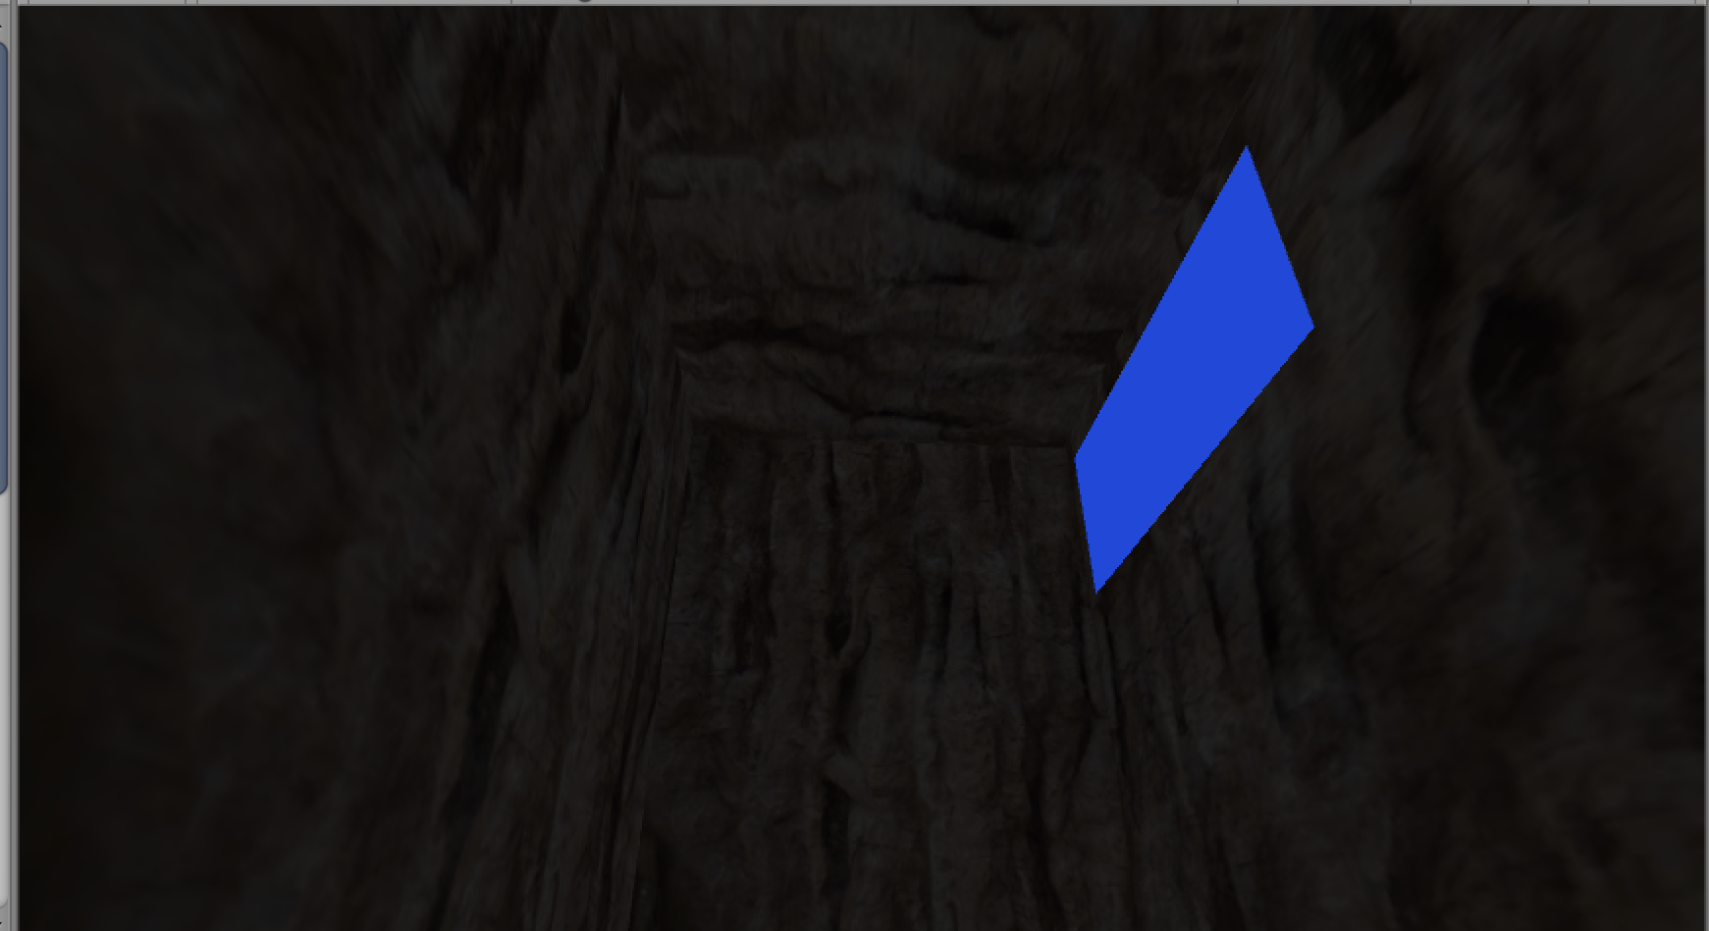

The house has a monitor which is an emissive material. The walls, floor and ceiling are all covered with normal maps and textures.

Terrain

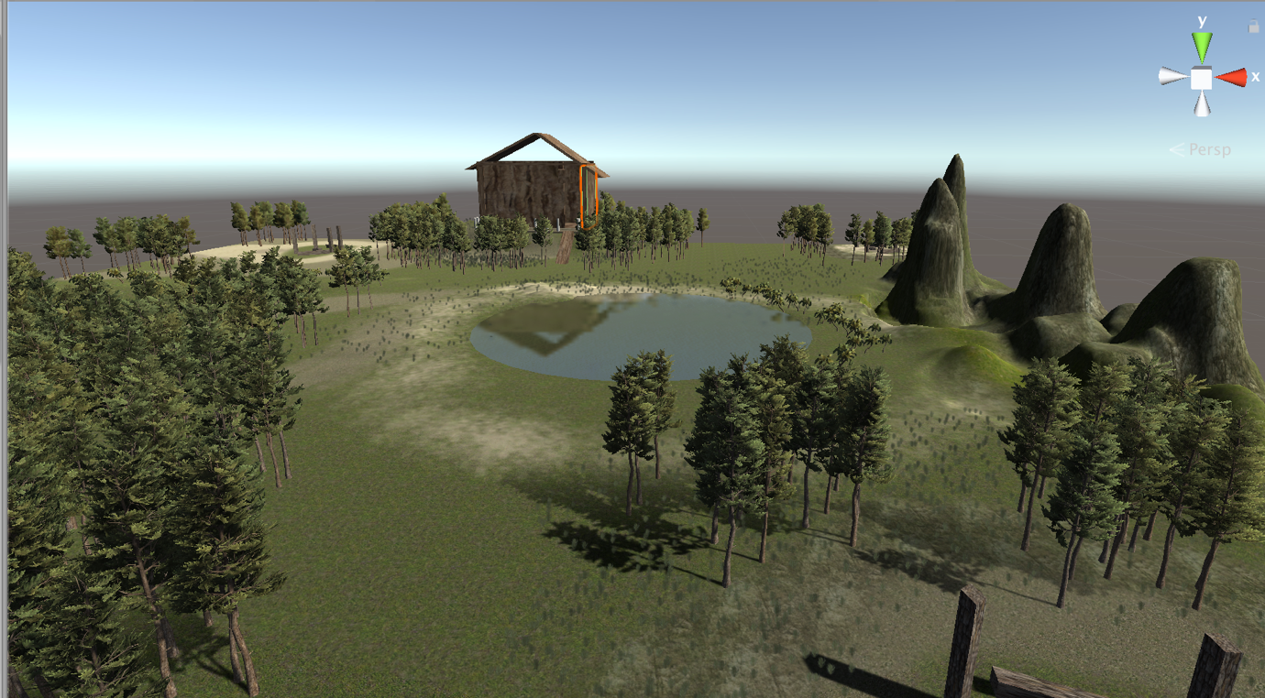

My terrain has an island theme with trees, grasses and bushes. I have a set of mountains located at one spot of the with a pond along with another washed away water area. The player will have to jump to reach the house and can also jump along the terrain were there are bumpy areas.

Fireplace

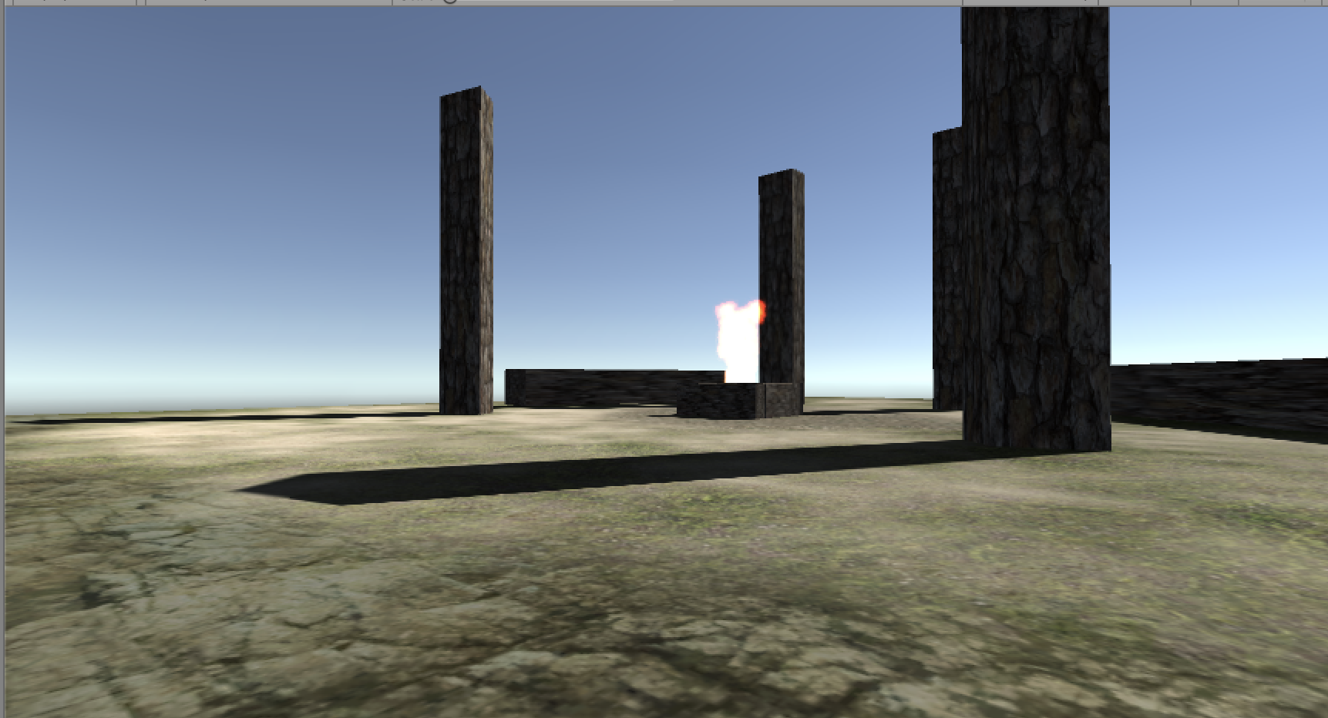

I created three fireplaces along the island which is relevant to the plot of my game by creating a particle system.

Rain

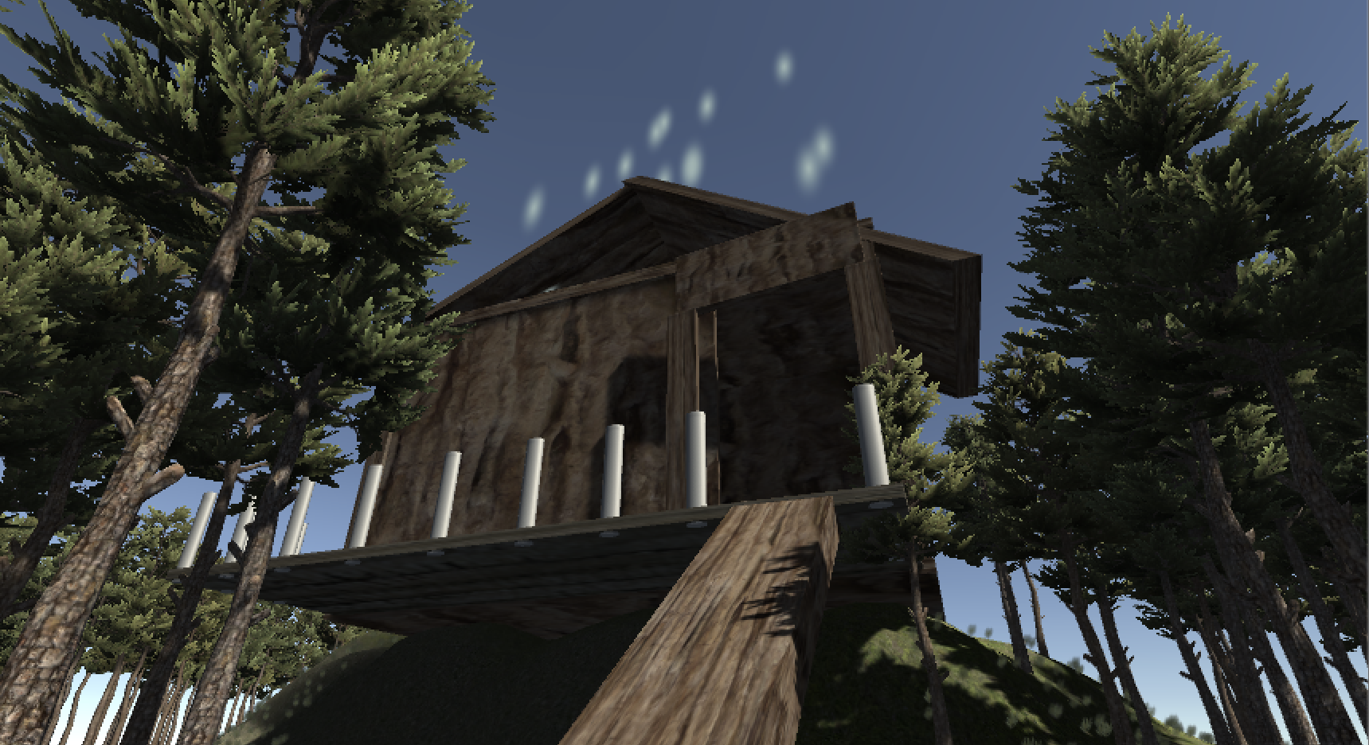

I created another particle system to add rain where the house is located.

Challenges and changes

I would have liked to add a few more things to what I have already put up in my project. I had planned for 3 or 4 enemies to hold survivors’ hostage near the fire areas. Other than that, I am pleased with the design that I have as I believe it will still allow the player to explore, use the jump button and experience fire, rain and the water as well.

Assets used

•  Terrain Assets by Unity Technologies.